MAC Address Table

A MAC-address is assigned to the Network Interface Card (NIC). It is a 48-bit address, and it is permanent. It is at a layer 2, data link layer, in the OSI Model.

Lab Purpose:

When switches boot, they have no directory of which MAC addresses are connected to which interface. As traffic enters the port, the switch adds the source MAC address to a MAC address table, so it doesn’t have to broadcast for the address next time.

Laboratory Tool: Cisco Packet Tracer

Tools Use: PC, switch

Procedure

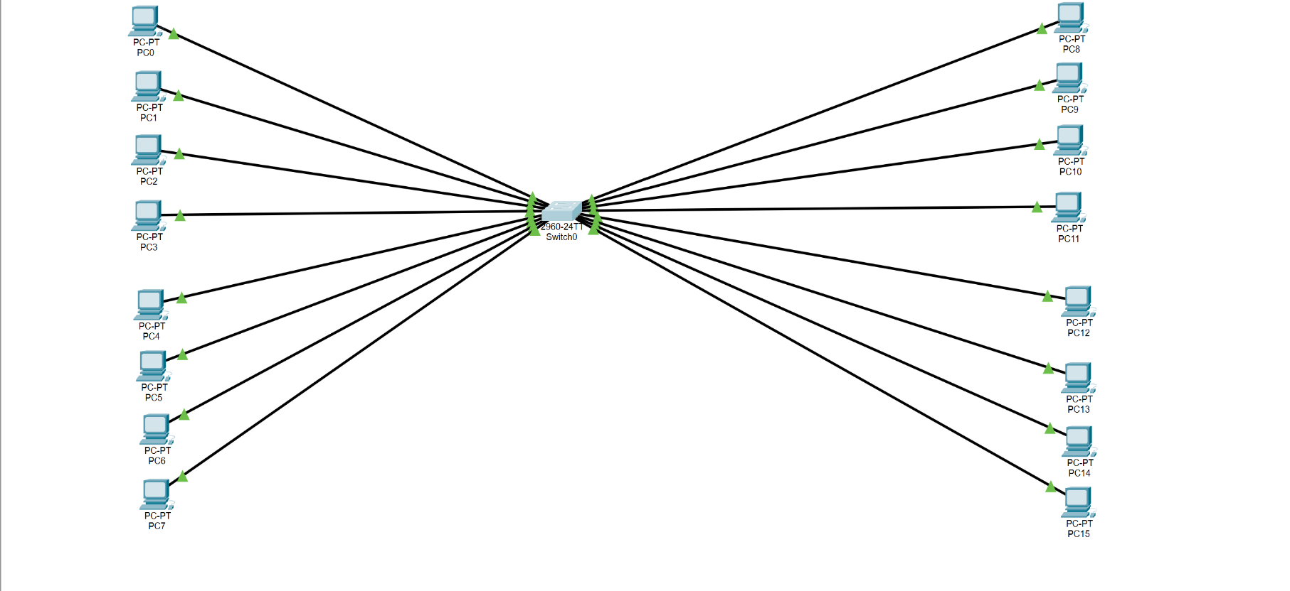
- I connected 16 PCs to a Cisco switch using straight-through cables.

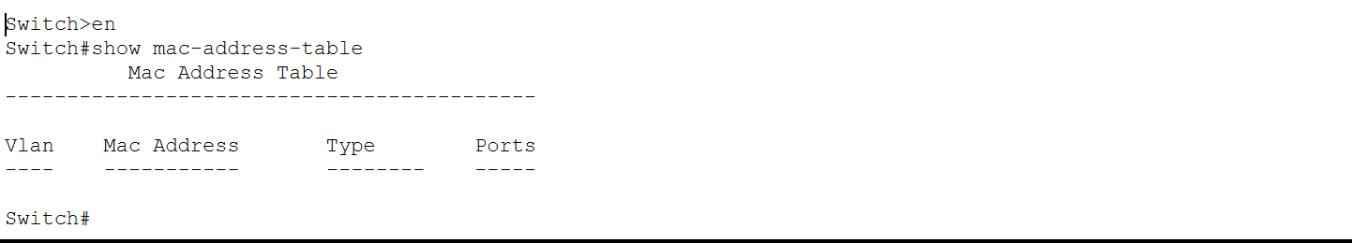
- I checked MAC address table on the switch. It should be empty at the moment.

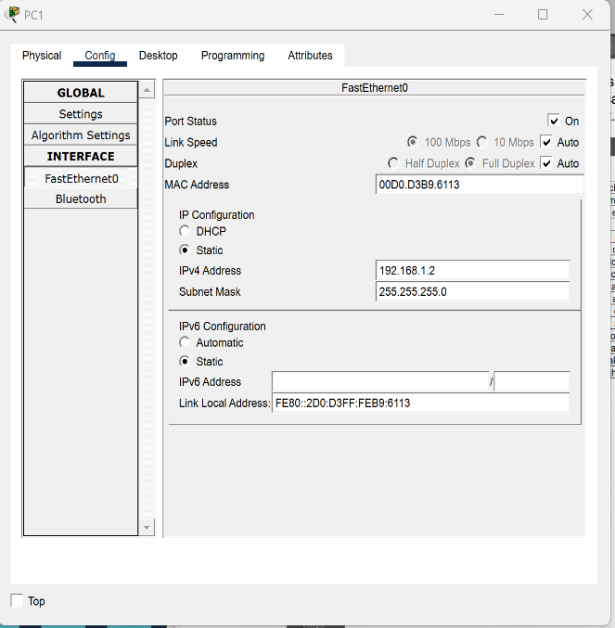
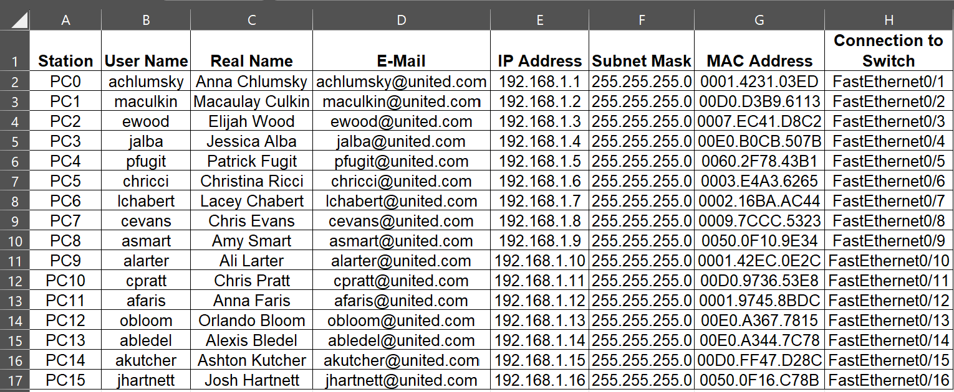
- I allocated IP addresses to the hosts starting at 192.168.1.1. Here is how I did it on every PC. After allocating IP addresses to it, I data entry the MAC address onto Excel spreadsheet.

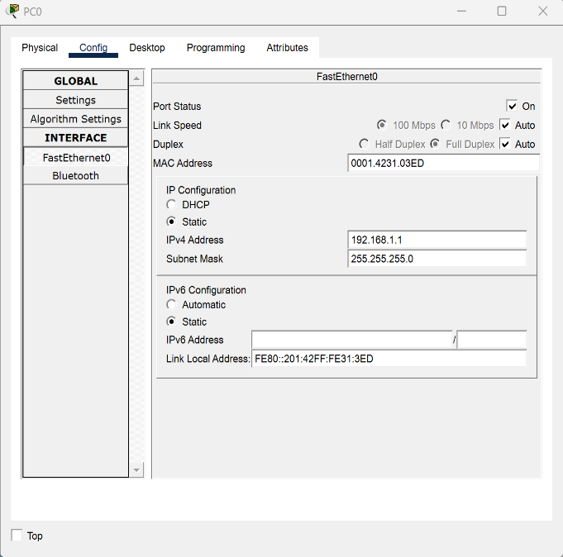

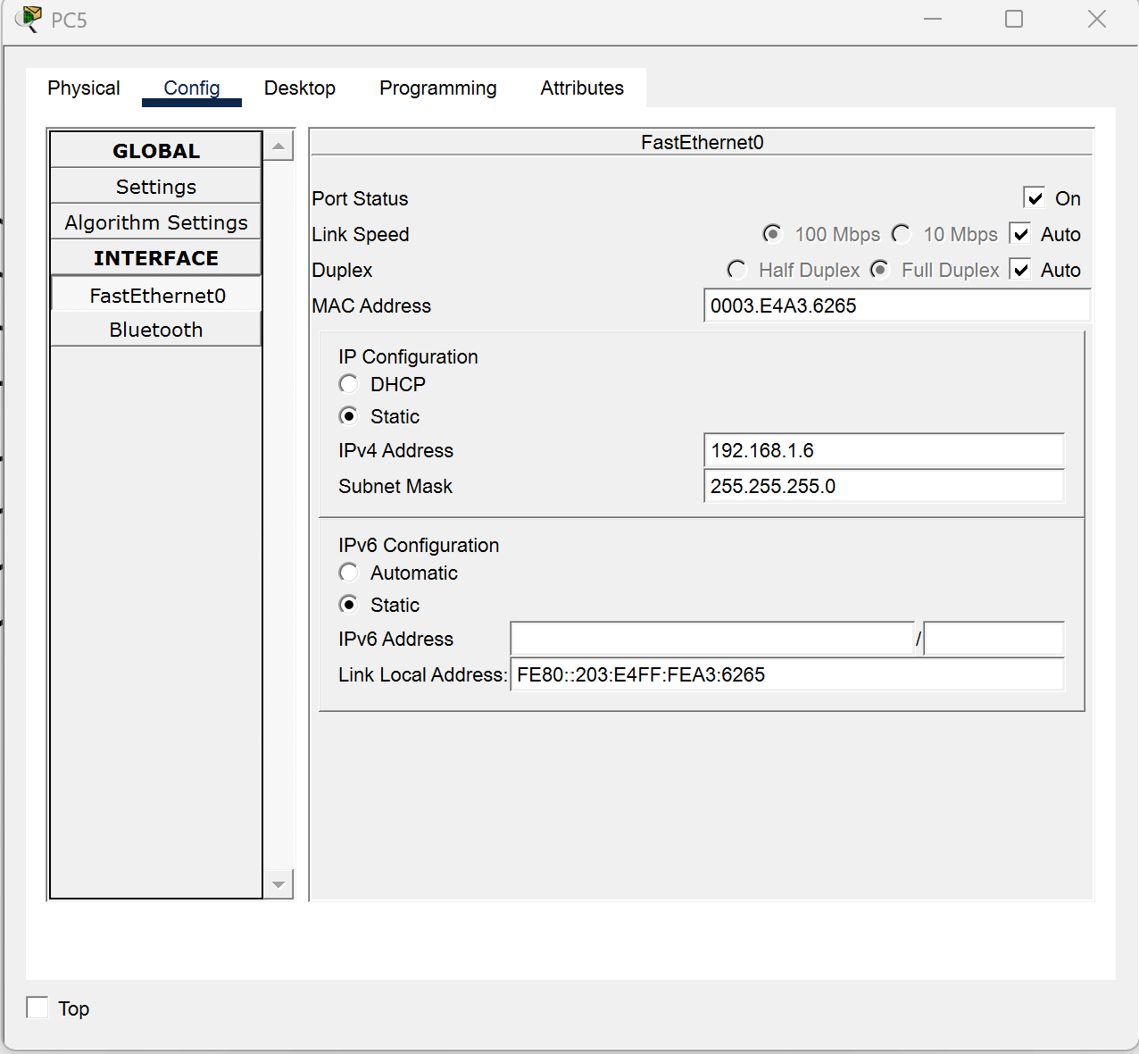
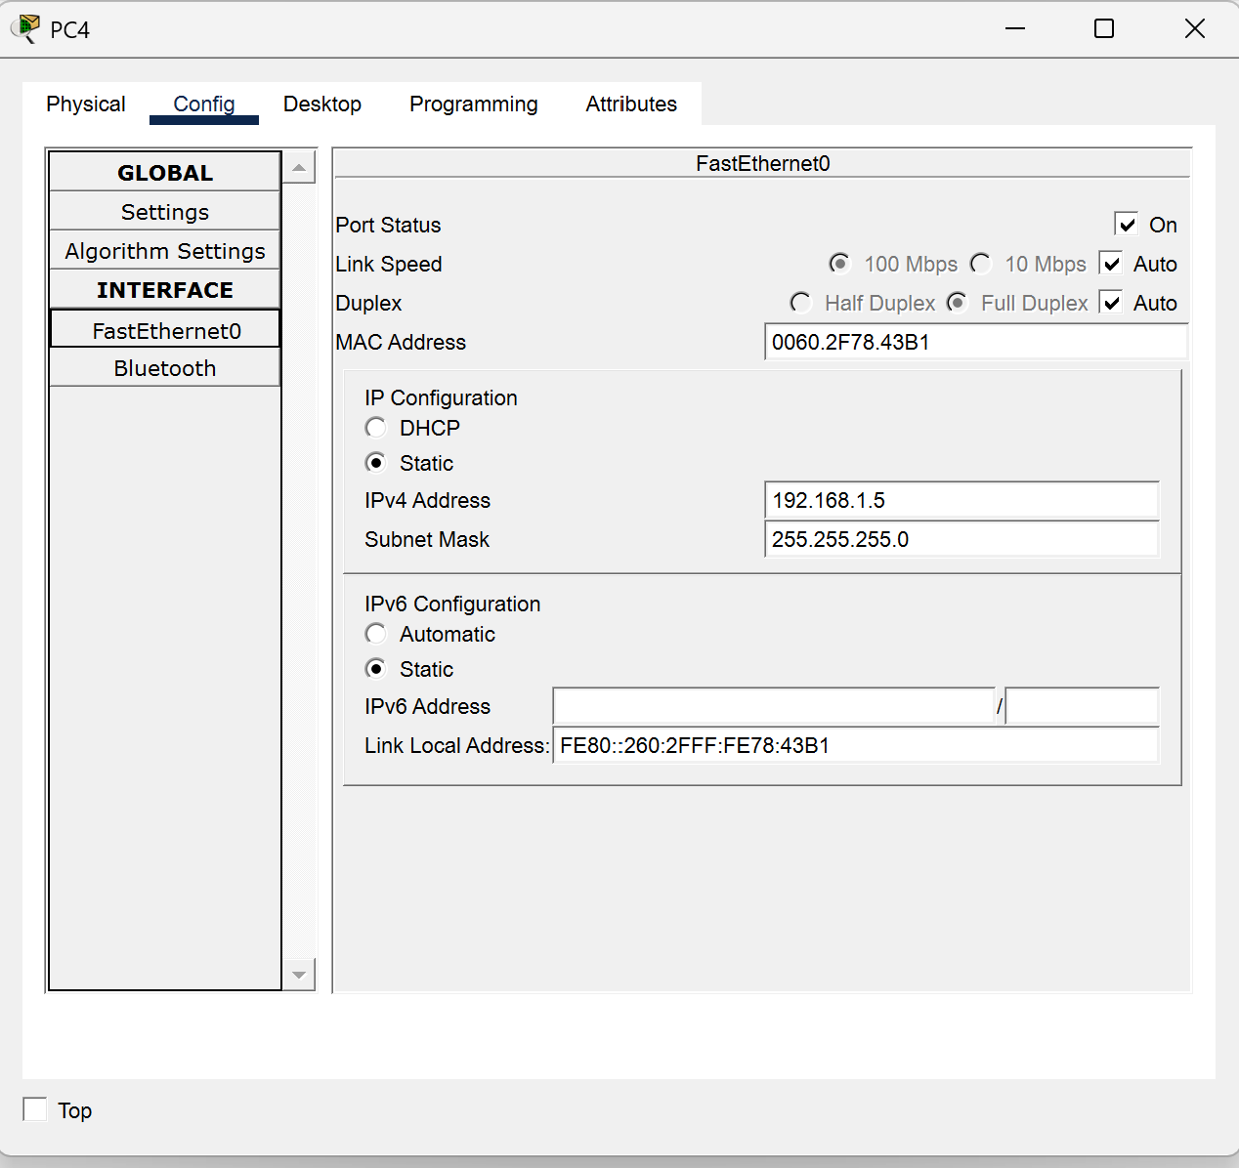
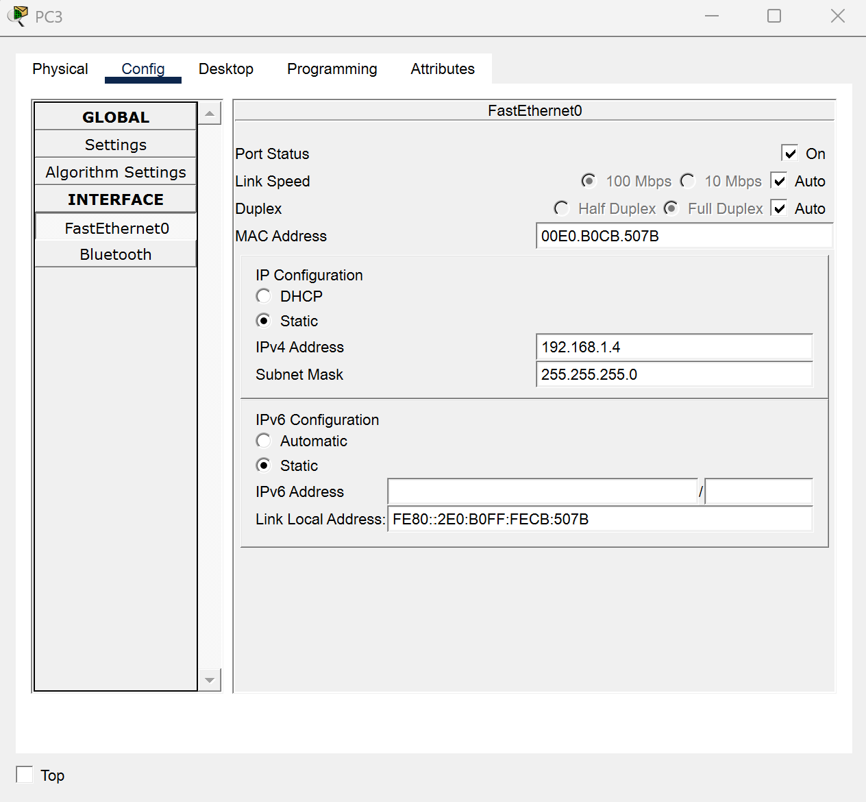
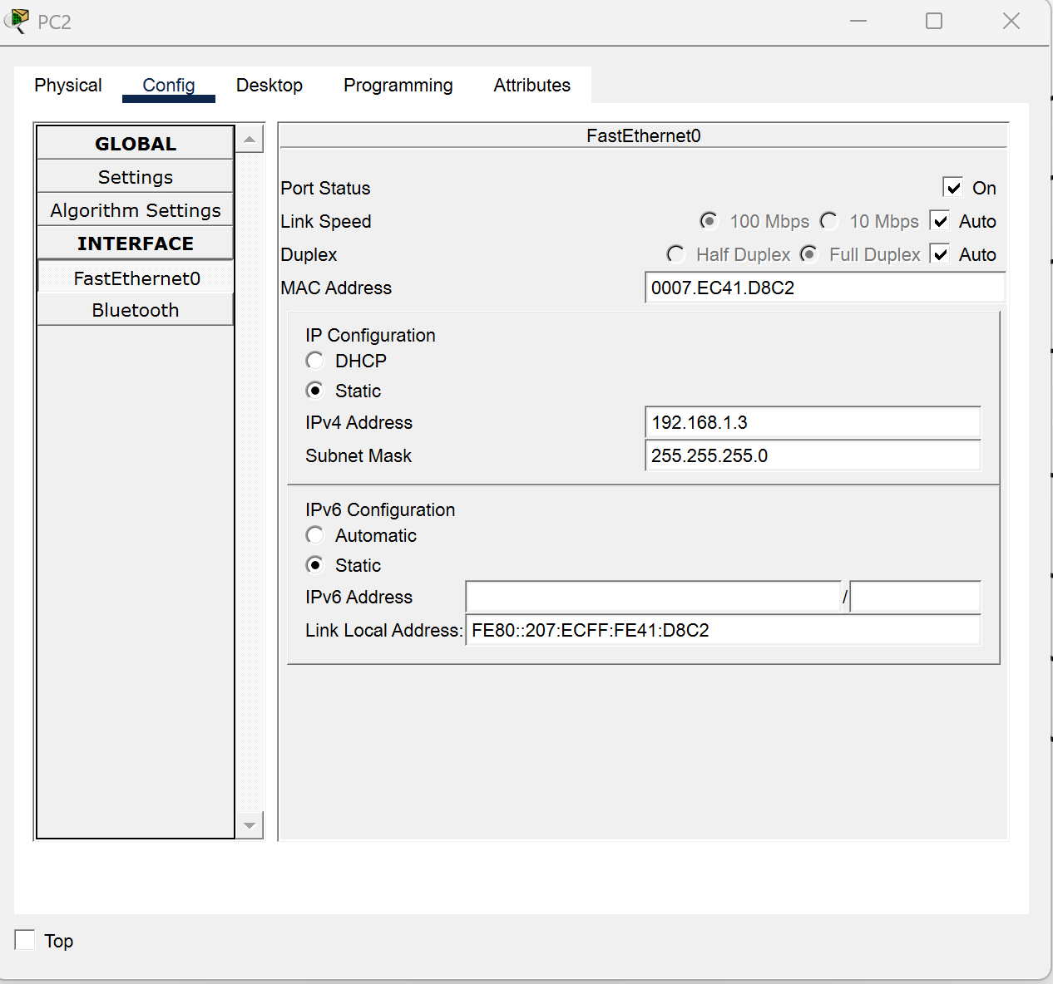

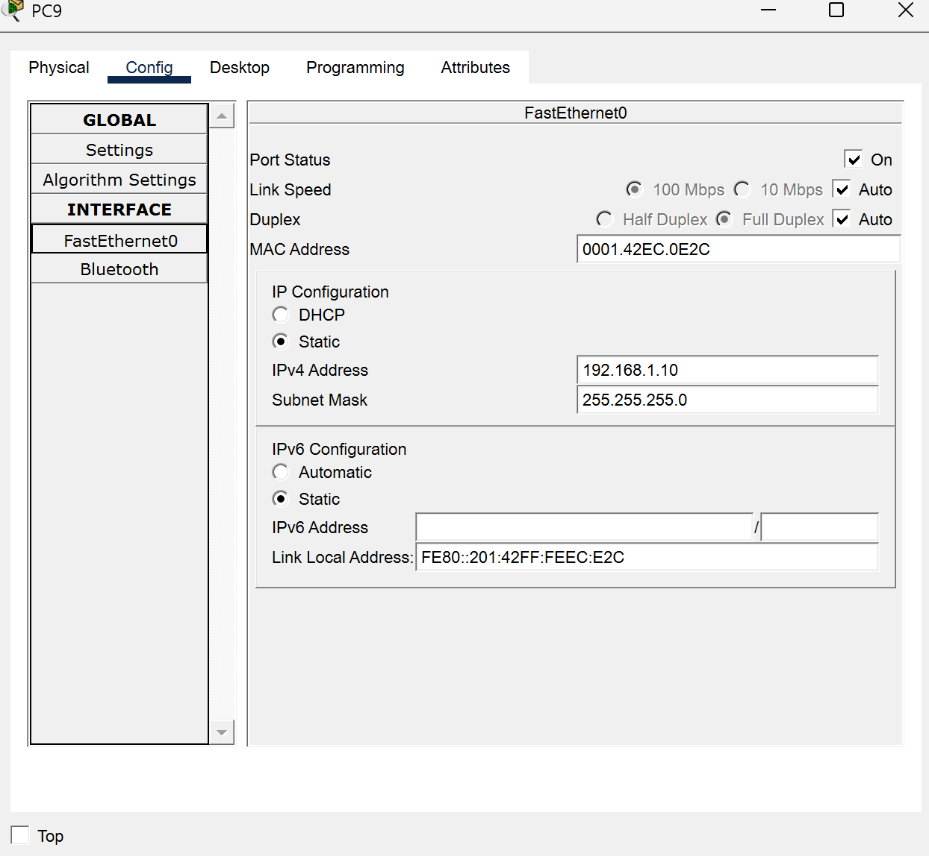
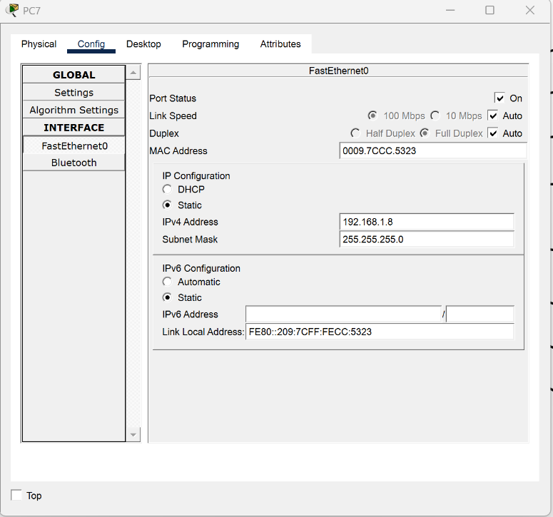
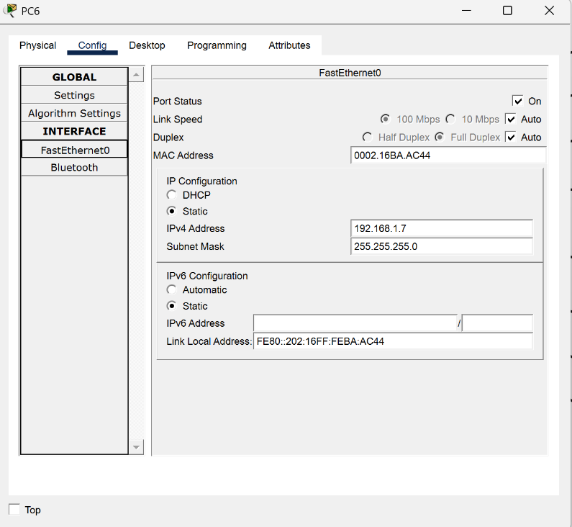
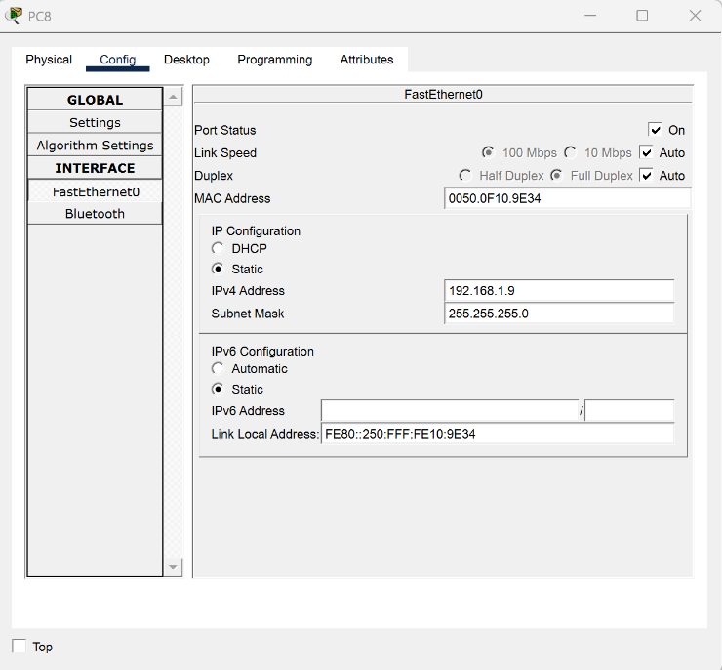

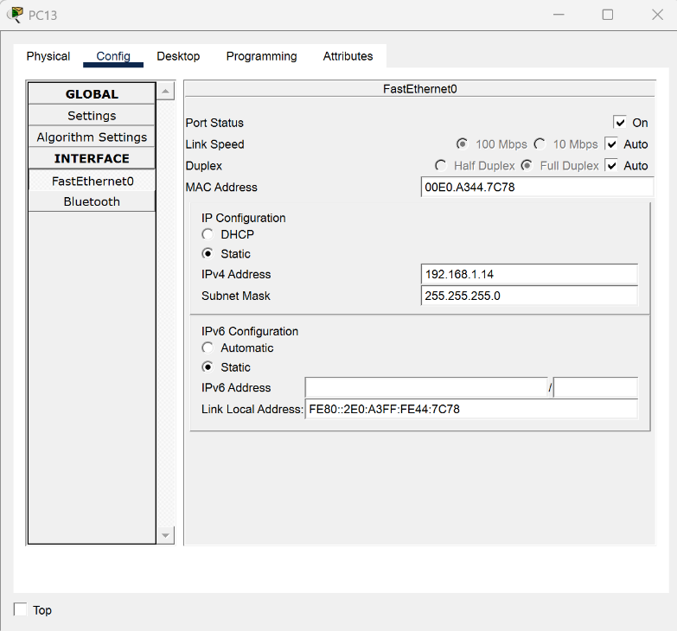
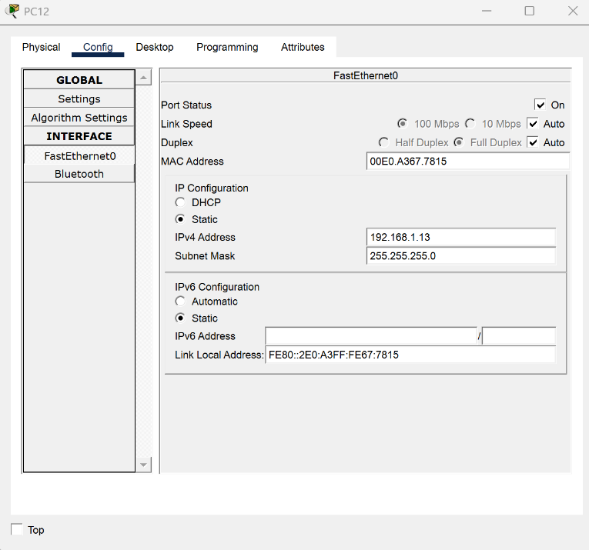
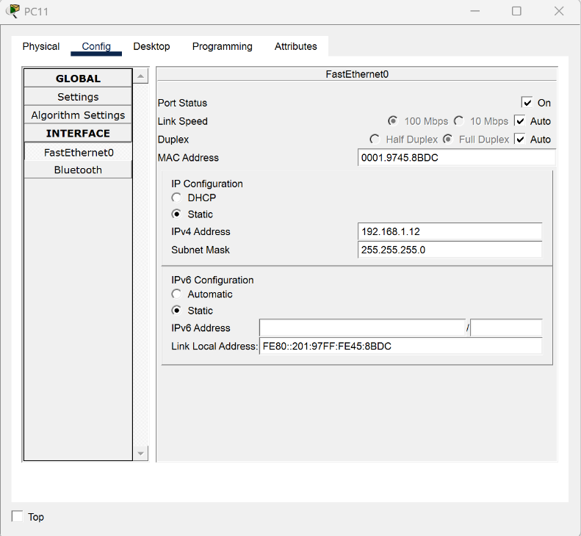
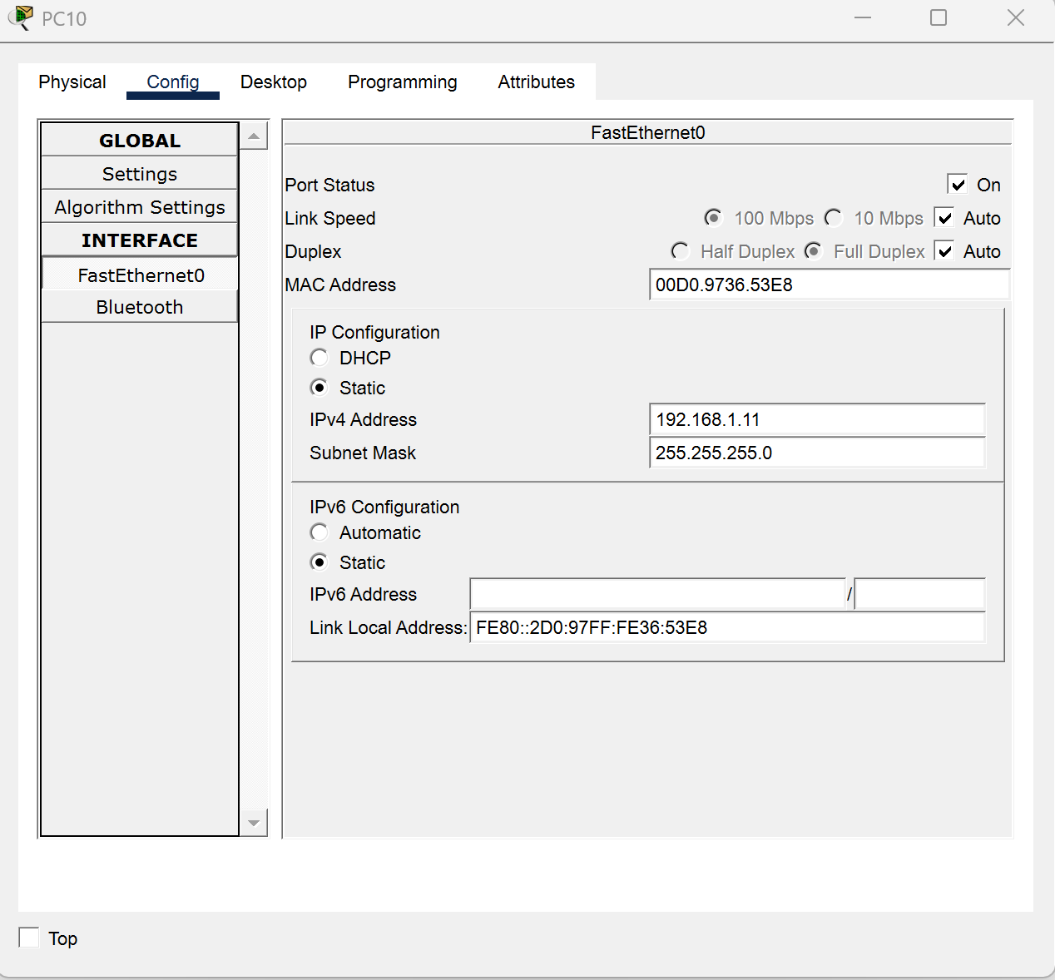

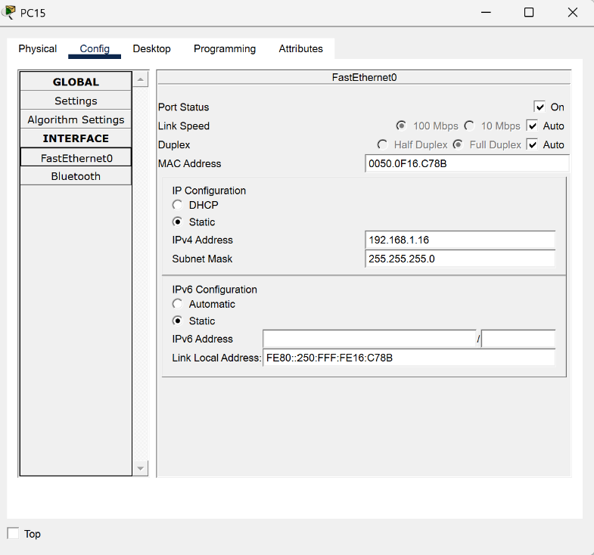
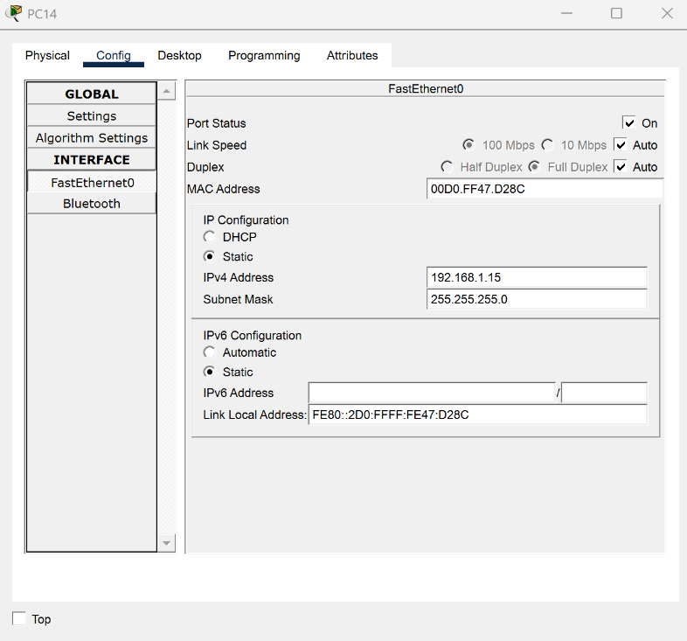

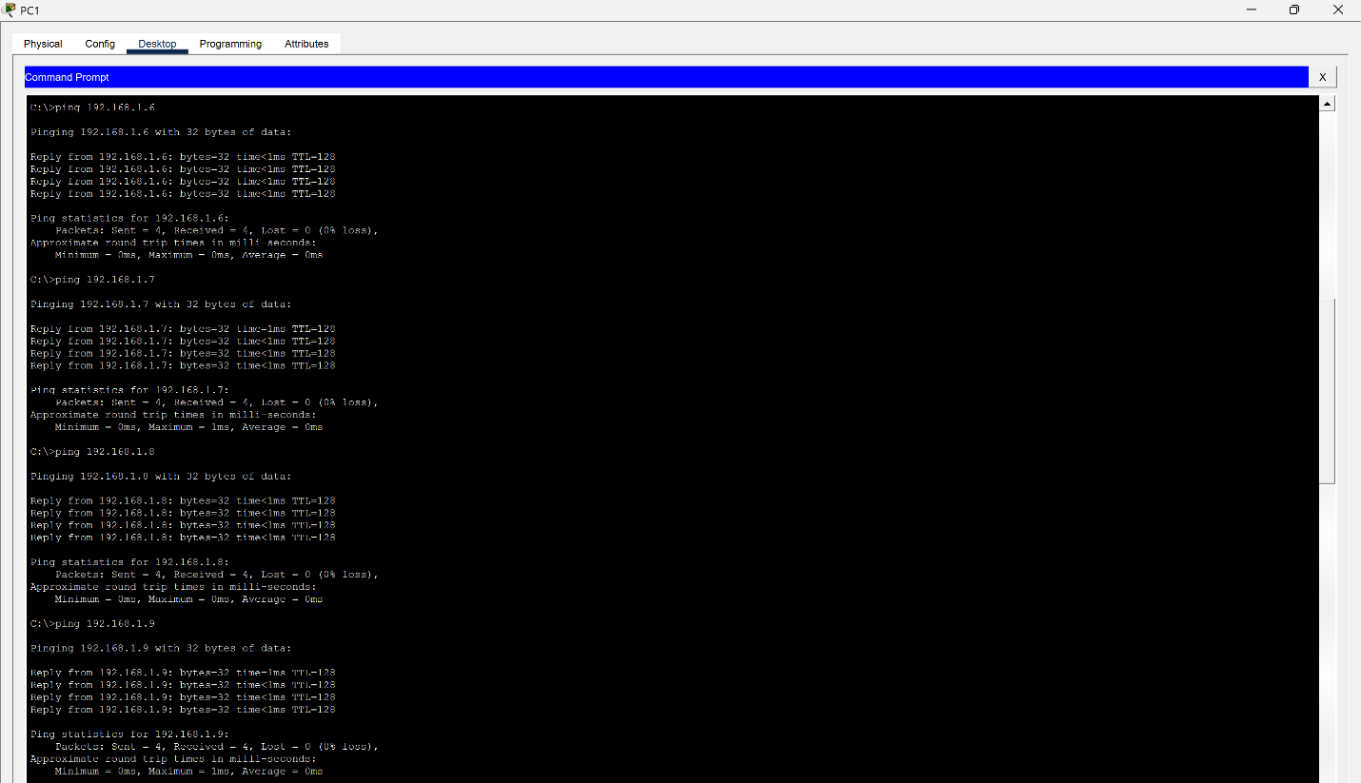
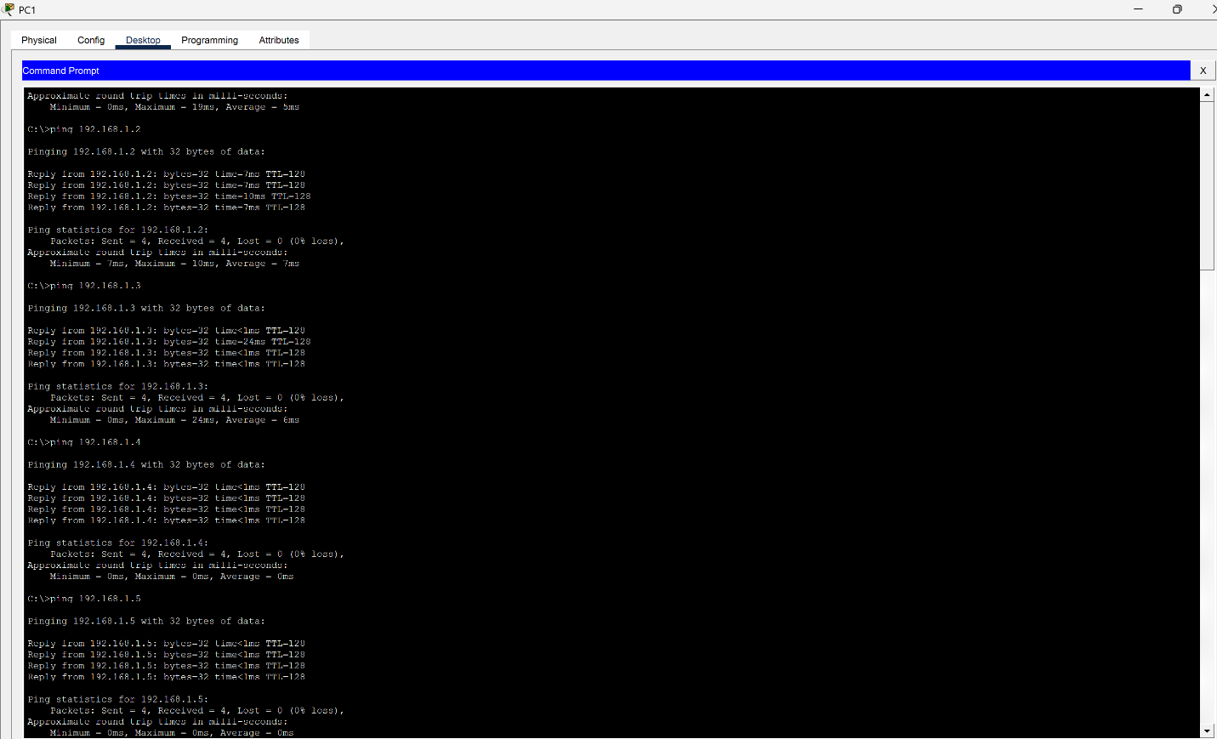
- From one of the PCs, I pinged 16 of it. For example, I used Macaulay Culkin to ping 16 of it.

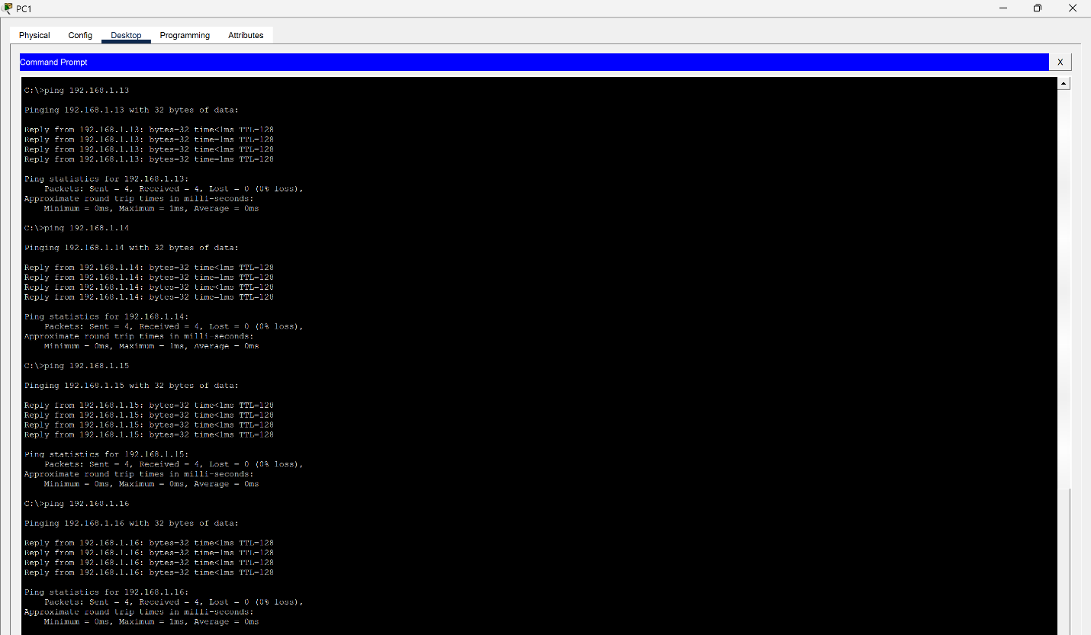
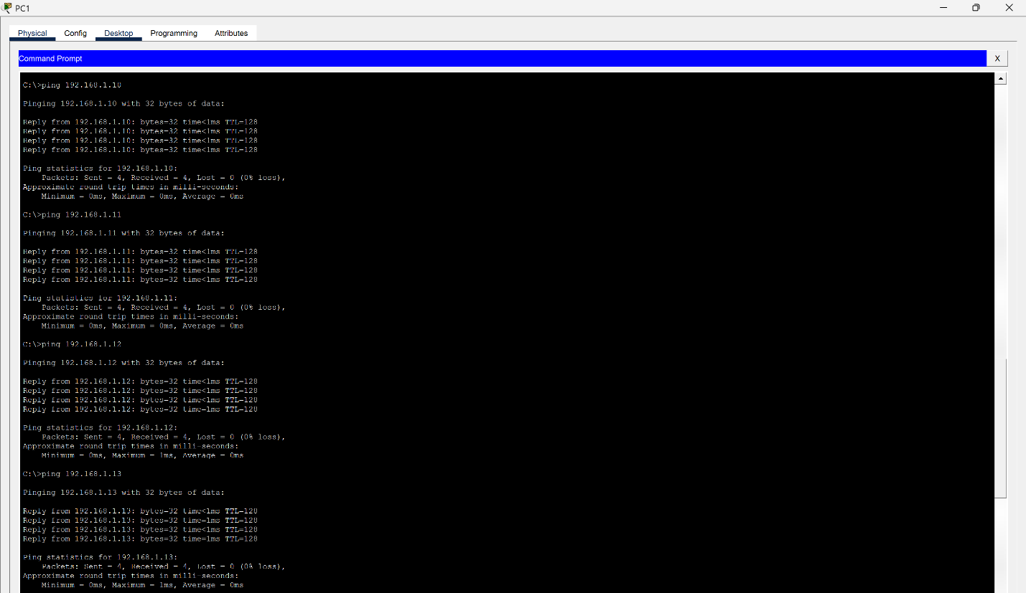

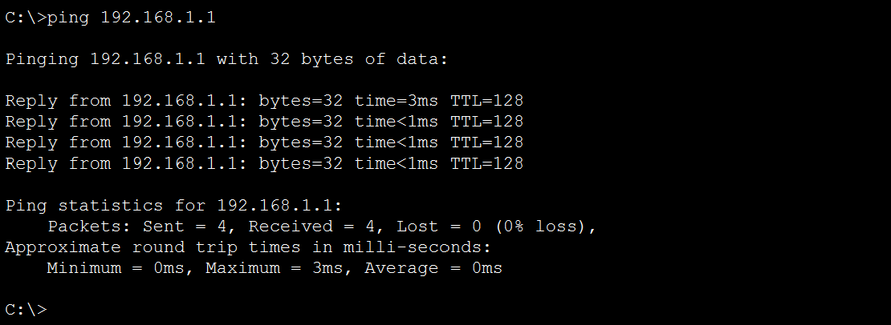

- I checked the MAC address table on the switch once more.
